ADITYA SRIRAM
191EE209

Assignment -1
April 07, 2020

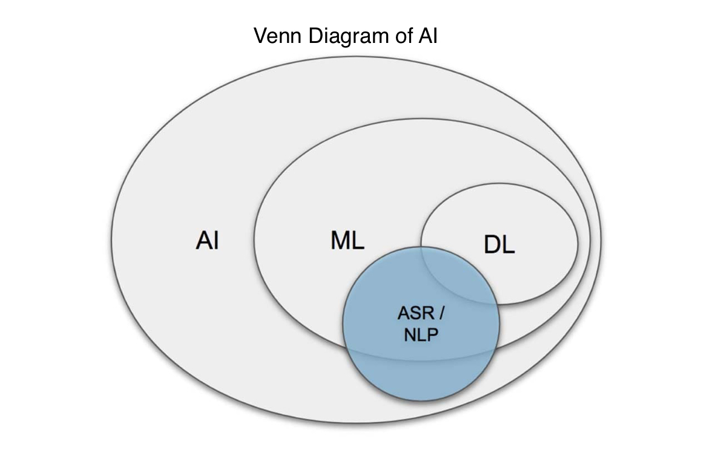

Is DEEP LEARNING going to replace MACHINE LEARNING ?
My answer is a straight NO.
There are both pros and cons to Machine Learning and Deep Learning.
The main advantage of deep learning is that it doesn’t necessarily need structured / tagged data.This is similar to how our human brain works to solve problems – running queries through different hierarchies of concepts and related questions to find the answer. Whereas Machine learning algorithms almost always require structured data.
Machine learning algorithms are designed to “learn” to act by understanding labeled data and then use it to produce new results with more datasets. However, when the result is incorrect, there is a need to “teach them”.
Deep learning networks do not require human intervention, as multilevel layers in neural networks place data in a hierarchy of different concepts, which ultimately learn from their own mistakes. However, even they can be wrong if the data quality is not good enough.
Data decides everything. It is the quality of the data that ultimately determines the quality of the result.
Because machine learning algorithms require bulleted data, they are not suitable for solving complex queries that involve a huge amount of data. In the same way, Deep Learning can’t be used for solving simple queries involving small amounts of data.

For an analogy, let’s consider :Ruby On Rails , which is a web-framework, which everyone thought that would die because of it’s less efficient features, age , convention over configurations, inability to handle large requests/users inefficiently whereas there are more frame-works in market like Django/Node JS which work more efficiently and offer more customization. But they are wrong, the number of rails developers needed in the Bay Area is increasing every year and GITHUB still runs on rails.

So I believe that Deep Learning might dominate Machine Learning but not entirely replace it.

Machine Learning | Deep Learning
Subset of AI | Subset of AI
Require structured/tagged data | Doesn’t necessarily require structured/tagged data
For small data sets | For large data sets
Require human intervention to train the model | Don’t require human intervention
Few/single algorithm | Uses ANN/many folds of neural networks

Pros and Cons in different methods of MACHINE LEARNING

Pros and Cons of Supervised Learning

PROS | CONS
Very helpful in classification problems | Supervised learning is limited in a variety of sense so that it can’t handle some of the complex tasks in machine learning.
Easy to understand or explain | Supervised learning cannot give you unknown information from the training data like unsupervised learning does
You can be very specific about the definition of classes,i.e you can train the classifier in such a way that it perfects the boundary | Less related to practical problems
After training you dont need to necessarily keep the training examples in your memory but can just use the decision boundary as a math formula, which is enough for future classification. | Computation time is high

Pros and Cons of Unsupervised Learning
PROS | CONS
It can detect those patterns which human brain can’t detect | It’s harder than supervised learning to understand or explain
It can give unexplored or unexpected results that can led to a revolution or disaster | It’s a costly affair
 | Less accuracy of the results. This is also because the input data is not known and not labeled by people in advance, which means that the machine will need to do this alone.

Pros and Cons of Reinforcement Learning
PROS | PROS
This learning model is very similar to the learning of human beings. Hence, it is close to achieving perfection | Too much reinforcement learning can lead to an overload of states which can diminish the results
The model can correct the errors occurred during the training process.So,once an error is corrected by the model, the chances of occurring the same error are very less | Needs a lot of data and computation
In the absence of a training dataset, it is bound to learn from its experience | Not for solving simple problems
Can be used to solve complex problems that conventional methods cannot solve

